MACHINE LEARNING LAB – 1
Question 1:
Create a NumPy array containing the integers from 1 to 20.
Perform the following operations:
1. Display the array.
2. Find the shape of the array.
3. Find the maximum and minimum values.
4. Calculate the mean and standard deviation.
5. Reshape the array into a 4 × 5 matrix.
6. Display the second row of the matrix.
7. Display the third column of the matrix.
Code:
import numpy as np
a = np.arange(1,21)
print("Array:")
print(a)
print("Shape:")
print(a.shape)
print("Maximum value:")
print(a.max())
print("Minimum value:")
print(a.min())
print("Mean:")
print(a.mean())
print("Standard Deviation:")
print(a.std())
b = a.reshape(4,5)
print("4 x 5 Matrix:")
print(b)
print("Second Row:")
print(b[1])
print("Third Column:")
print(b[:,2])
OUTPUT:
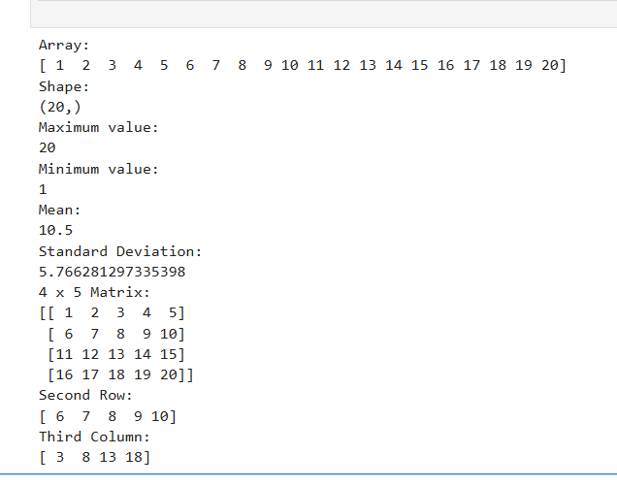
Question 2:
Create two NumPy arrays:
A = [10, 20, 30, 40, 50]
B = [5, 10, 15, 20, 25]
Perform:
1. Addition of A and B.
2. Subtraction of B from A.
3. Element-wise multiplication.
4. Element-wise division.
5. Find the sum of all elements in A
Code:
import numpy as np
A = np.array([10, 20, 30, 40, 50])
B = np.array([5, 10, 15, 20, 25])
print("Addition:")
print(A + B)
print("Subtraction:")
print(A - B)
print("Multiplication:")
print(A * B)
print("Division:")
print(A / B)
print("Sum of elements in A:")
print(A.sum())
Output:
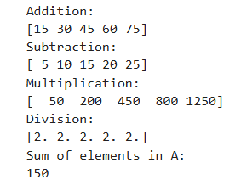
Question 3:
Create a DataFrame using the following student data:
Roll No Name Marks
101 Ravi 85
102 Priya 92
103 Kiran 78
104 Anu 88
105 Sita 95
Perform the following operations:
1. Display the DataFrame.
2. Display the first three records.
3. Find the average marks.
4. Find the student with the highest marks.
5. Find the student with the lowest marks.
6. Add a new column called "Grade" using:
A for Marks ≥ 90
B for Marks between 80 and 89
C for Marks < 80
Code:
import pandas as pd
data = {
"Roll No": [101, 102, 103, 104, 105],
"Name": ["Ravi", "Priya", "Kiran", "Anu", "Sita"],
"Marks": [85, 92, 78, 88, 95]
}
df = pd.DataFrame(data)
print("DataFrame")
print(df)
print("\nFirst Three Records")
print(df.head(3))
print("\nAverage Marks")
print(df["Marks"].mean())
print("\nStudent with Highest Marks")
print(df[df["Marks"] == df["Marks"].max()])
print("\nStudent with Lowest Marks")
print(df[df["Marks"] == df["Marks"].min()])
grade = []
for m in df["Marks"]:
if m >= 90:
grade.append("A")
elif m >= 80:
grade.append("B")
else:
grade.append("C")
df["Grade"] = grade
print("\nDataFrame with Grade")
print(df)
Output:
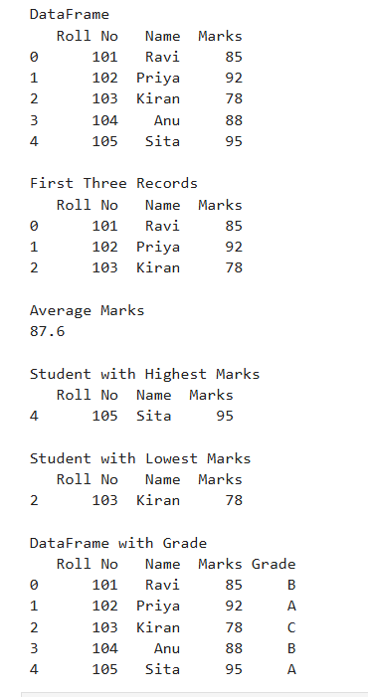
Question 4:
Create a DataFrame containing the following information:
Product Price Quantity
Laptop 50000 10
Mouse 500 50
Keyboard 1200 30
Monitor 10000 15
Perform:
1. Calculate the total value of each product using:
Total Value = Price × Quantity
2. Add the Total Value column.
3. Find the product with the highest total value.
4. Calculate the overall inventory value.
Code:
import pandas as pd
data = [
["Laptop", 50000, 10],
["Mouse", 500, 50],
["Keyboard", 1200, 30],
["Monitor", 10000, 15]
]
df = pd.DataFrame(data, columns=["Product", "Price", "Quantity"])
df["Total Value"] = df["Price"] * df["Quantity"]
print("Product Data:")
print(df)
print("\nProduct with Highest Total Value:")
print(df[df["Total Value"] == df["Total Value"].max()])
print("\nOverall Inventory Value:")
print(df["Total Value"].sum())
Output:
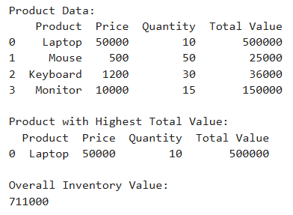

Question 5:
Download the Iris dataset from Scikit-learn and perform the following:
1. Load the dataset into a Pandas DataFrame.
2. Display the first five records.
3. Find the number of rows and columns.
4. Display column names.
5. Check for missing values.
6. Generate summary statistics using describe().
7. Find the number of samples belonging to each class
Code:
from sklearn.datasets import load_iris
import pandas as pd
iris = load_iris()
df = pd.DataFrame(iris.data, columns=iris.feature_names)
df["Target"] = iris.target
print("First Five Records:")
print(df.head())
print("\nNumber of Rows and Columns:")
print(df.shape)
print("\nColumn Names:")
print(df.columns)
print("\nMissing Values:")
print(df.isnull().sum())
print("\nSummary Statistics:")
print(df.describe())
print("\nNumber of Samples in Each Class:")
print(df["Target"].value_counts())
Output:
